Practical
3. Develop a C program using fork() that creates a parent and child process. Display the Process ID (PID), Parent Process ID (PPID), and process states at different stages of execution.
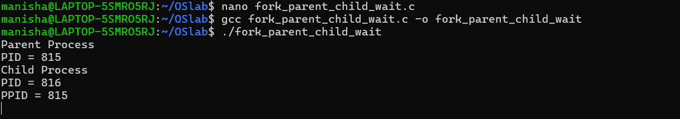
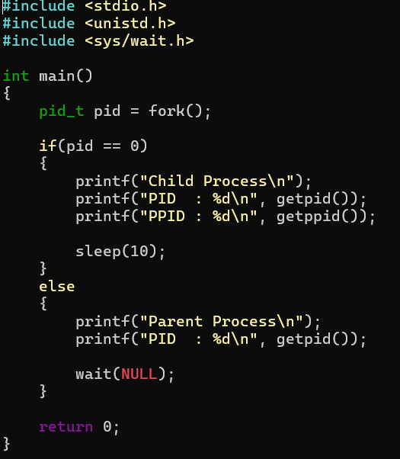

4. Write a C program where a parent process creates multiple child processes and synchronizes their completion using wait() and waitpid(). Compare the behavior of both functions.
